Collecting Audience In-Market Segments

December 2022

Website/SEO Assignments

NAME: Tahiya Rahman

horizontal line

# About the Data

The data depicts NSTEM's demographics hold the highest market leads and has the potential probability to increase in future. The Purpose of the paper is to find out user acquisition, user behavior, and user conversion, segments that bring in the largest amount of new users or have the highest conversion rates, most valuable affinity categories for our website audience and over time, which segment proves to be the most receptive demographics. The data contains time periods such as the week from December 25th, 2022 to January 1st, 2023.

# Comparison of Data over Different Time Periods

December 25th, 2022, to January 1st, 2023

**User Acquisition:**

From the user acquisition data, as shows the highest users are from Education/Post-Secondary Education along with the users, the segments has the biggest number and the first lead for the new use and the most sessions used by the audience.

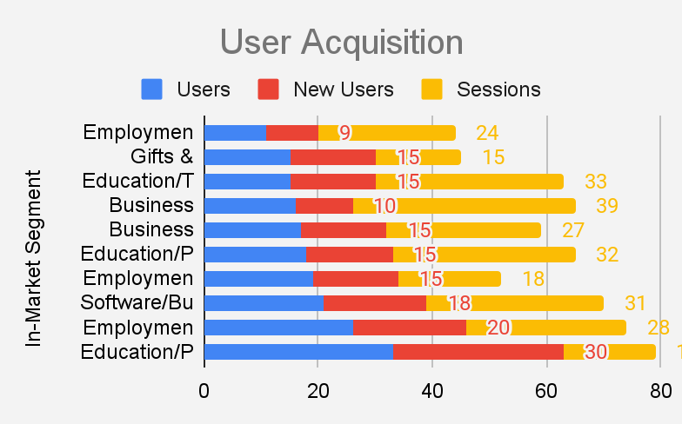

The other successful segment for the acquisition is the Employment/Career Consulting Services, Software/Business & Productivity Software. As it was the last week of the year of 2022, the student and the parents were more likely to invest time on the employment searches and the chapter merchandise.

It is possible that the students are looking for more opportunities for internships for the new year and other employment opportunities. Besides this data, there was another observation on the segment of Business Services/Business Technology/Enterprise Software/Collaboration & Conferencing Tools which is an obvious deep drive for more research.

**User Behavior:**

I was able to observe that the user behavior is different from the user acquisition which means that we get more segments who are showing interest in the website. The lead segment is from Business Services/Business Technology/Enterprise Software/Collaboration & Conferencing Tools, seems to be the new potential lead.

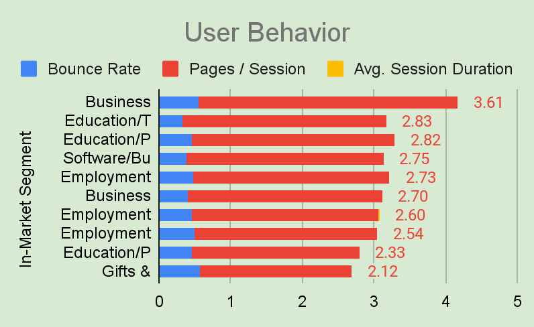

# 

# User Conversions:

The conversion rate data was not sufficient to create a result. So, I have created the conversions form the user acquisition and the user behavior data.

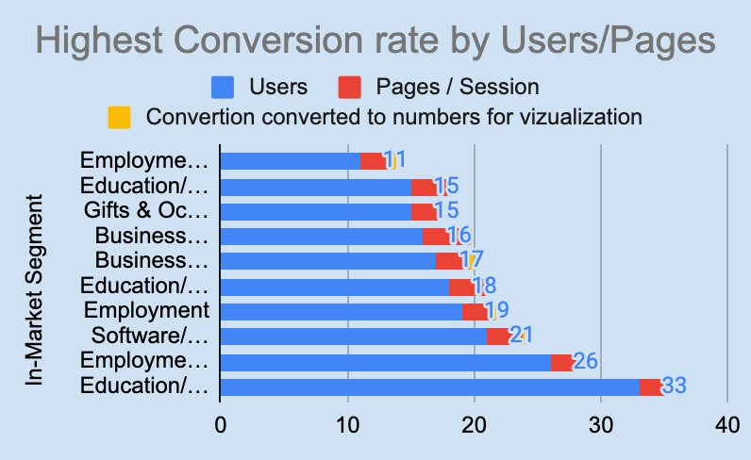

From the calculations, the data shown as Education/Post-Secondary Education get the highest conversion rate by user behavior from the pages per session. Another new segment was Employment/IT & Technical Jobs and Software/Business & Productivity Software.

**Receptive demographics:**

To understand the receptive demographics, I have created a trendline where the user behavior and page per session performance was included. The reason the page/session was included was to know what are the segments the most sessions are using for and the most session users can become the lead drivers or the most interested audience in the NSTEM products and services.

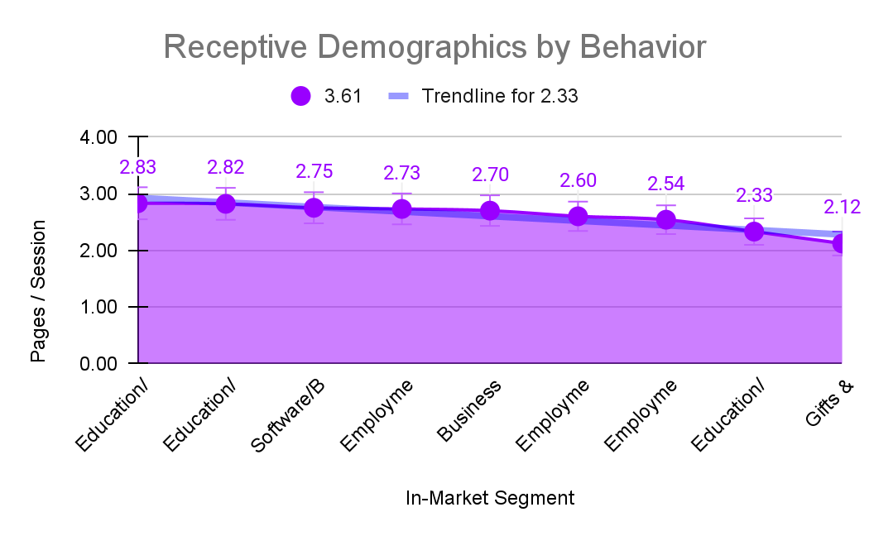

The trendline helps to prove that there are market segments who are interested in buying the products and services such as chapters and seeking employment opportunities within NSTEM.

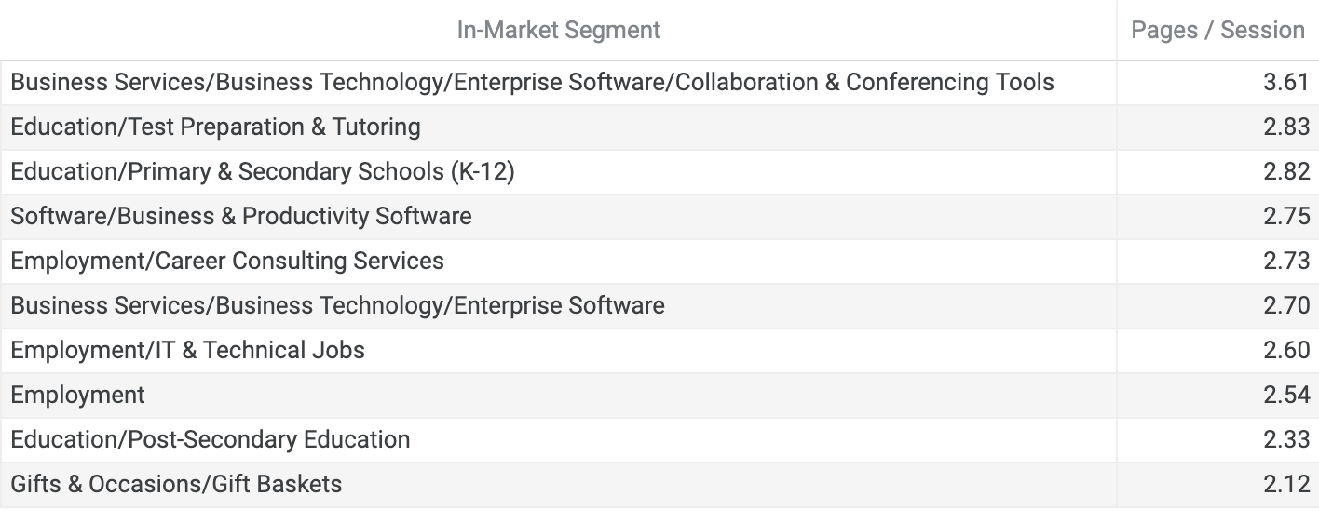

Only the least interest showing in the market segment is the Gifts and Occasions/Gift Baskets, the segment was also shown on other analyses for user acquisition, user behavior, and conversions as the least lead driver and below the trendline.

**Most Valuable Affinity Group:**

By combining the two sets of data from user acquisition and the behavior, I was able to observe the highest amount of the in market user by sessions. The audience and the movements by the activities were active rather than the data showing two factors where the lines were steady such as page/sessions and average session duration. These two factors can be skipped as we can see the other factors can get a decent result.

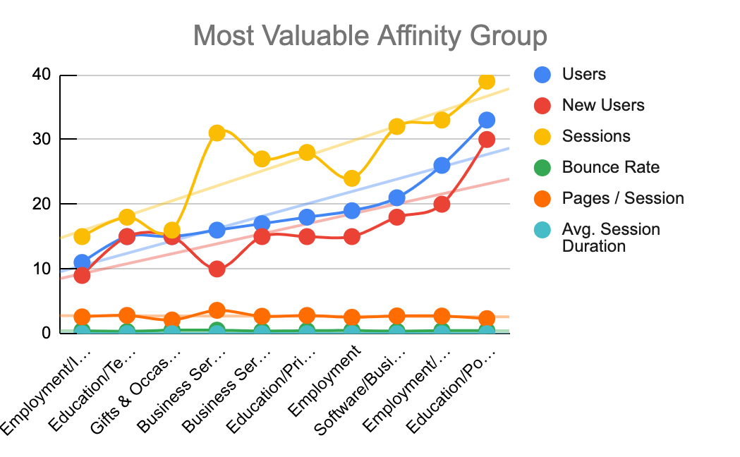

The most significant in market driver is from the Education/Primary & Secondary Schools (K-12) and Business Services/Business Technology/Enterprise Software/Collaboration & Conferencing Tools which was way above the trendline. But if we look at the data of Business Services/Business Technology/Enterprise Software/Collaboration & Conferencing Tools, there is a drop in new users to 10 which can be a subject matter to investigate.

# What NSTEM Should Continue Doing

* NSTEM should continue making partnerships with schools, colleges and universities and heavily invest on promotion or word of mouth.
* Because the employment and business services segment rates were higher in terms of sessions per page, NSTEM should create more employment opportunities through training, workshops, and sponsors.

# Ways to Improve the Website

* As shown, NSTEM has an unexpected drop in the new users for one of the lead segments for business services, it needs to investigate with analysis.
* Create cards only for the analysis on a particular reason for the drop in new users or bounce rate rather than create fanatics for every month for the whole market.

# 

# 

# 

# 

# 

# 

# 

# 

# Data that Stands Out From Data Studio

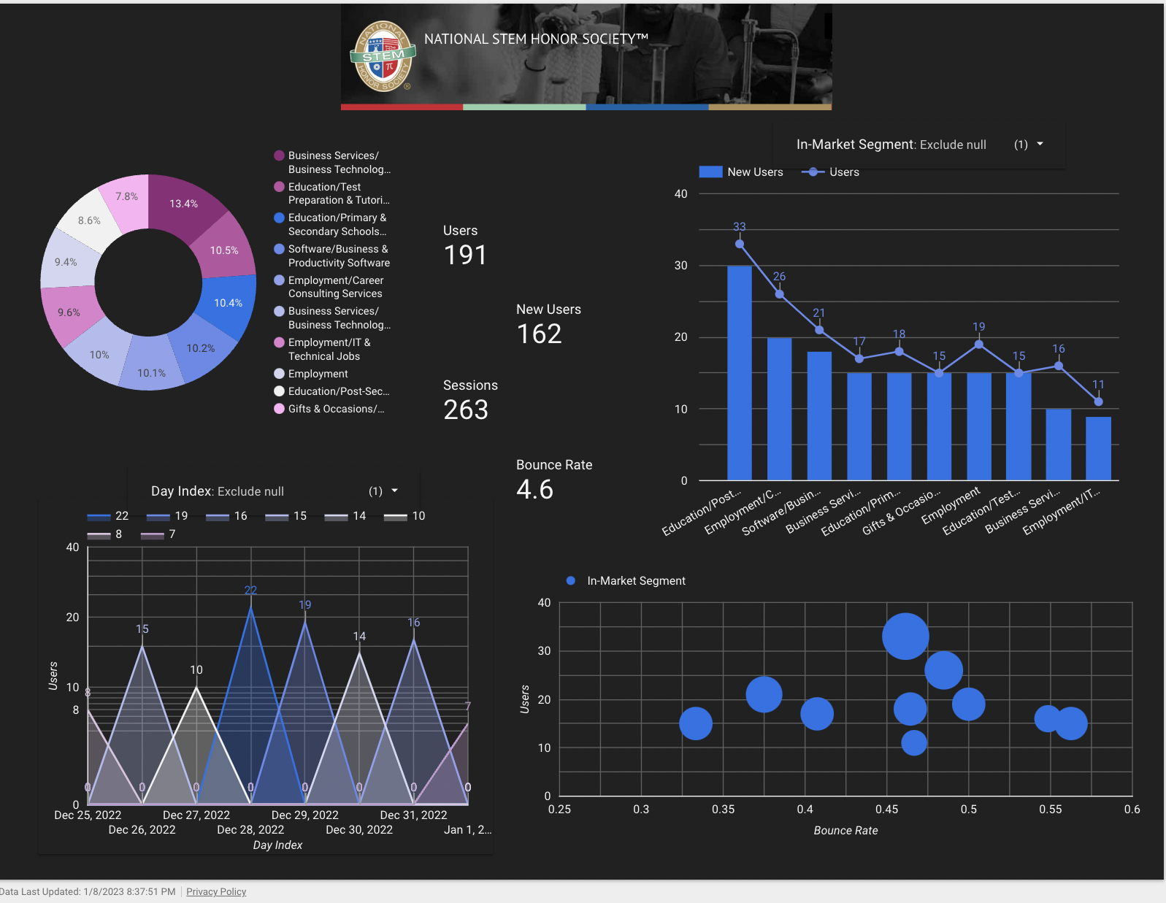

According to the data from December 2022, the session rate shows a 13.4% for the business services which proves NSTEM has created attention for the business opportunities. NSTEM can offer different software companies and employment agencies for partnerships where students can get hired through the training from NSTEM.

# Conclusion

From the analysis of December last week of 2022, the data tells us that business services along with high school education, these two segments need to be nourished, invested can create more leads for NSTEM.

Google Sheets: <https://docs.google.com/spreadsheets/d/1xVGxxg8KUOrVCbTbfLEIwDVDxIa9bYiUImeVbKsimJE/edit?usp=sharing>

Google data studio: <https://datastudio.google.com/u/0/reporting/619f75f6-dde9-4b6f-b722-660288c46fce/page/ng3BD>